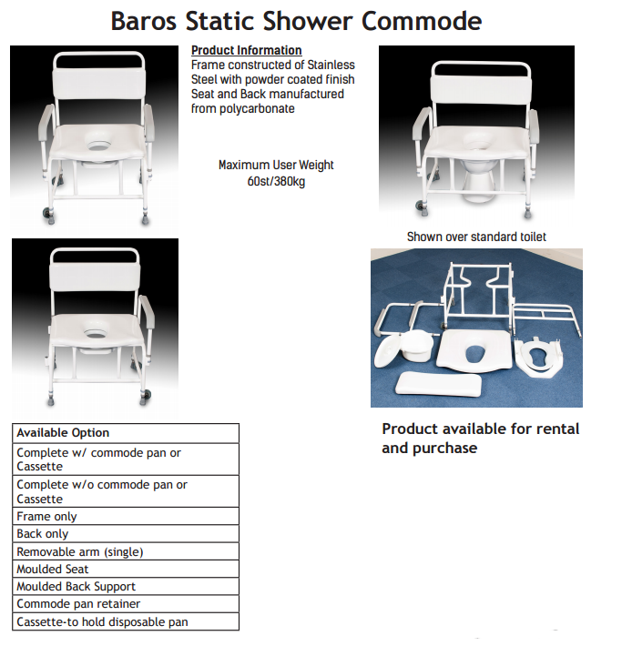

The Old Creamery, Tanyard, Millstreet Town, Co Cork Ireland P51 D328
Telephone +353 0(29) 21799
Email: info@oflynnmedical.com www.oflynnmedical.com

